### **DAILY PROJECT ACTIVITY IS FROM PAGE 21 IN THIS DOC**

### **1. Kubernetes Basics and Core Concepts**

* **What is Kubernetes?**
  + Overview of Kubernetes
  + Use Cases and Benefits
* **Kubernetes Architecture Recap**
  + Master Node Components
  + Worker Node Components
* **Kubernetes API Server**
  + Function and Role
  + Interaction with Kubectl
* **Kubernetes Objects and Resources**
  + Pods
  + ReplicaSets
  + Deployments
  + Namespaces
  + Services

### **2. Kubernetes CLI (kubectl) Commands**

* **Basic kubectl Commands**
  + kubectl get, kubectl describe, kubectl logs
* **Managing Resources**
  + Create, Update, Delete Resources
* **Namespace Management**
  + Creating and Switching Namespaces

### **3. Configuring and Managing Pods**

* **Pod Lifecycle**
  + Creation, Running, Termination
* **Pod Configurations**
  + YAML Files, Labels, Annotations
* **Pod Networking**
  + Communication Between Pods
  + Network Policies

### **4. Deployments and ReplicaSets**

* **Creating Deployments**
  + Basic Deployment Configuration
* **Scaling Deployments**
  + Manual and Automatic Scaling
* **Managing ReplicaSets**
  + Rolling Updates and Rollbacks

### **5. Services and Networking**

* **Service Types**
  + ClusterIP, NodePort, LoadBalancer, ExternalName
* **Network Policies**
  + Defining and Implementing Policies

### **6. Configuration Management**

* **ConfigMaps**
  + Creating and Using ConfigMaps
* **Secrets Management**
  + Creating and Using Secrets
* **Environment Variables and Volumes**

### **7. Storage Solutions in Kubernetes**

* **Persistent Volumes (PVs) and Persistent Volume Claims (PVCs)**
  + Creating and Managing PVs and PVCs
* **Storage Classes**
  + Default vs. Custom Storage Classes

### **8. Advanced Pod Management**

* **Init Containers**
  + Use Cases and Configurations
* **Sidecar Containers**
  + Patterns and Implementations
* **Pod Disruption Budgets**

### **9. Helm and Package Management**

* **Introduction to Helm**
  + Helm Charts, Repositories, and Releases
* **Using Helm to Deploy Applications**
  + Installing, Upgrading, and Rolling Back Helm Charts

### **10. Monitoring and Logging**

* **Monitoring Tools**
  + Prometheus, Grafana Integration
* **Logging Solutions**
  + Fluentd, ELK Stack Integration

### **11. Security and Best Practices**

* **Pod Security Policies**
  + Implementing and Managing Policies
* **Role-Based Access Control (RBAC)**
  + Roles, RoleBindings, and ClusterRoles
* **Security Contexts and Network Policies**

### **12. Continuous Integration and Continuous Deployment (CI/CD)**

* **CI/CD Pipelines in Kubernetes**
  + Tools and Integration
* **Automating Deployments**
  + GitOps with ArgoCD, Flux

### **13. Kubernetes Networking**

* **Network Models and Concepts**
  + Overlay Networks, CNI Plugins
* **Ingress Controllers**
  + Setting Up and Managing Ingress Rules

### **14. Advanced Kubernetes Topics**

* **Kubernetes Federation**
  + Overview and Use Cases
* **Custom Controllers and Operators**
  + Creating and Managing Operators
* **Kubernetes API Extensions**
  + CRDs and Aggregated APIs

### **15. Kubernetes Troubleshooting and Maintenance**

* **Common Issues and Troubleshooting**
  + Logs Analysis, Debugging Pods
* **Cluster Maintenance**
  + Upgrades, Backup and Restore Strategies

### **16. Scaling Kubernetes and Cloud Providers**

* **Horizontal and Vertical Scaling**
  + Auto-scaling Mechanisms
* **Integration with Cloud Providers**
  + AWS, GCP, Azure Specific Integrations

### **17. Kubernetes in Production**

* **Best Practices for Production Deployments**
  + High Availability, Disaster Recovery
* **Cost Management and Optimization**

### **Basic Structure of a Kubernetes YAML Configuration File**

apiVersion: <api-version>

kind: <resource-kind>

metadata:

name: <resource-name>

namespace: <namespace> # Optional

labels: # Optional

<label-key>: <label-value>

spec:

<spec-field>: # Specification fields specific to the resource type

<subfield>: <value>

...

### **1. Pods**

#### **What is a Pod?**

* **Definition**: A Pod is the smallest and simplest Kubernetes object. It represents a single instance of a running process in the cluster.
* **Components**:
  + **Container**: Runs the application or service.
  + **Storage Volumes**: Shared storage accessible by containers in the Pod.
  + **Networking**: A unique IP address for communication between Pods.

#### **Example**

apiVersion: v1

kind: Pod

metadata:

name: my-app-pod

spec:

containers:

- name: my-app-container

image: nginx:latest

ports:

- containerPort: 80

#### **Use Cases**

* **Basic Application Deployment**:
  + **Example**: Running a simple web server or API service.
  + **Use Case**: Deploying a static website using Nginx.
* **Debugging and Development**:
  + **Example**: Running a single container for debugging or development.
  + **Use Case**: Creating a Pod to test a container image before deploying it with more complex configurations.

### **2. ReplicaSets**

#### **What is a ReplicaSet?**

* **Definition**: A ReplicaSet ensures that a specified number of Pod replicas are running at any given time.
* **Purpose**: Maintains a stable set of replica Pods running at any given time.

#### **Example**

apiVersion: apps/v1

kind: ReplicaSet

metadata:

name: my-app-replicaset

spec:

selector:

matchLabels:

app: my-app

replicas: 3

template:

metadata:

labels:

app: my-app

spec:

containers:

- name: my-app-container

image: nginx:latest

ports:

- containerPort: 80

#### **Use Cases**

* **Application Availability**:
  + **Example**: Ensuring multiple instances of a web application are always running.
  + **Use Case**: Scaling a web server to handle increased traffic.
* **Self-Healing Mechanism**:
  + **Example**: Automatically replacing failed Pods.
  + **Use Case**: Ensuring that if a Pod crashes, another one is created to replace it.

### **3. Deployments**

#### **What is a Deployment?**

* **Definition**: A Deployment manages ReplicaSets and provides declarative updates to applications.
* **Purpose**: Automates the process of scaling applications, rolling updates, and rollbacks.

#### **Example**

apiVersion: apps/v1

kind: Deployment

metadata:

name: my-app-deployment

spec:

replicas: 3

selector:

matchLabels:

app: my-app

template:

metadata:

labels:

app: my-app

spec:

containers:

- name: my-app-container

image: nginx:latest

ports:

- containerPort: 80

#### **Use Cases**

* **Application Upgrades**:
  + **Example**: Updating a web server’s image from version 1.0 to 2.0.
  + **Use Case**: Rolling out new features or bug fixes without downtime.
* **Rolling Back Changes**:
  + **Example**: Reverting to a previous version of an application.
  + **Use Case**: Rolling back if a new deployment introduces issues.

### **4. Namespaces**

#### **What is a Namespace?**

* **Definition**: A Namespace is a way to divide cluster resources between multiple users or projects.
* **Purpose**: Helps in resource isolation and organization.

#### **Example**

apiVersion: v1

kind: Namespace

metadata:

name: development

#### **Use Cases**

* **Multi-Tenancy**:
  + **Example**: Creating separate environments for development, testing, and production.
  + **Use Case**: Different teams can work on the same cluster without interfering with each other’s resources.
* **Resource Management**:
  + **Example**: Quotas and limits on resources for different teams.
  + **Use Case**: Setting resource quotas for each team or environment to manage usage.

### **5. Services**

#### **What is a Service?**

* **Definition**: A Service is an abstraction that defines a logical set of Pods and a policy by which to access them.
* **Purpose**: Ensures reliable networking and load balancing between Pods.

#### **Example**

apiVersion: v1

kind: Service

metadata:

name: my-app-service

spec:

selector:

app: my-app

ports:

- protocol: TCP

port: 80

targetPort: 80

type: ClusterIP

#### **Use Cases**

* **Internal Communication**:
  + **Example**: Exposing a web application to other Pods within the same cluster.
  + **Use Case**: Services allow Pods to communicate with each other and with external systems.
* **Load Balancing**:
  + **Example**: Distributing traffic among multiple Pods.
  + **Use Case**: Creating a Service to balance the load for a web application among several instances.

#### **Service Type**

* **ClusterIP**: Default type, only accessible within the cluster.
* **NodePort**: Exposes the Service on each Node’s IP at a static port.
* **LoadBalancer (Cloud Specific)**: Provisioned by cloud providers to expose the Service externally.
* **ExternalName**: Maps the Service to an external DNS name.

### **ClusterIP: Default type, only accessible within the cluster**

**Use Case**: **Internal Microservice Communication**

* **Scenario**: You have a set of microservices deployed within your Kubernetes cluster that need to communicate with each other but do not need to be accessible from outside the cluster.
* **Example**: You have a backend service called backend-service that needs to communicate with a database service called db-service.

apiVersion: v1

kind: Service

metadata:

name: db-service

spec:

type: ClusterIP

selector:

app: database

ports:

- protocol: TCP

port: 5432

targetPort: 5432

### **NodePort: Exposes the Service on each Node’s IP at a static port**

**Use Case**: **Direct Access for Testing or Development**

* **Scenario**: You are in a development or testing environment and need to access a service directly on a specific port on any node in the cluster.
* **Example**: You want to expose a simple web application running in your cluster on port 30007 so it can be accessed from outside the cluster.

apiVersion: v1

kind: Service

metadata:

name: web-service

spec:

type: NodePort

selector:

app: web

ports:

- protocol: TCP

port: 80

targetPort: 80

nodePort: 30007

### **LoadBalancer: Provisioned by cloud providers to expose the Service externally**

**Use Case**: **Public Access to a Production Service**

* **Scenario**: You have a production application that needs to be accessible from the internet. You are using a cloud provider that supports LoadBalancer services.
* **Example**: You want to expose your production web application to the internet using a cloud provider's load balancer.

apiVersion: v1

kind: Service

metadata:

name: prod-web-service

spec:

type: LoadBalancer

selector:

app: prod-web

ports:

- protocol: TCP

port: 80

targetPort: 80

### **ExternalName: Maps the Service to an external DNS name**

**Use Case**: **External Dependency Integration**

* **Scenario**: You have an application running in your cluster that needs to connect to an external service (e.g., a third-party API or an external database) via a DNS name.
* **Example**: You want your application to connect to an external MySQL database hosted outside the cluster at mysql.external.com.

apiVersion: v1

kind: Service

metadata:

name: external-mysql

spec:

type: ExternalName

externalName: mysql.external.com

### **Deployment Strategies Types**

### **1. Rolling Update Deployment**

#### **Definition:**

Rolling updates allow updating the application to a new version gradually, replacing Pods one at a time with minimal downtime.

#### **Characteristics:**

* **Incremental:** Updates Pods incrementally to the new version.
* **Minimal Downtime:** Ensures some Pods are always available during the update.
* **Rollback Capability:** Can roll back to the previous version if something goes wrong.

#### 

#### 

#### **Example:**

apiVersion: apps/v1

kind: Deployment

metadata:

name: rolling-update-deployment

namespace: my-namespace

spec:

replicas: 3

selector:

matchLabels:

app: my-app

template:

metadata:

labels:

app: my-app

spec:

containers:

- name: my-container

image: nginx:1.14.2

ports:

- containerPort: 80

strategy:

type: RollingUpdate

rollingUpdate:

maxSurge: 1

maxUnavailable: 1

#### **Use Case:**

When you want to update an application with minimal disruption.

### **2. Recreate Deployment**

#### **Definition:**

Recreate deployments delete all existing Pods before creating new ones. This strategy ensures that no old Pods are running alongside the new Pods.

#### **Characteristics:**

* **Downtime:** Causes a temporary downtime because old Pods are terminated before new ones are created.
* **Simplified Process:** Useful for applications where downtime is acceptable.

#### **Example:**

apiVersion: apps/v1

kind: Deployment

metadata:

name: recreate-deployment

namespace: my-namespace

spec:

replicas: 3

selector:

matchLabels:

app: my-app

template:

metadata:

labels:

app: my-app

spec:

containers:

- name: my-container

image: nginx:1.14.2

ports:

- containerPort: 80

strategy:

type: Recreate

#### **Use Case:**

Suitable for applications that cannot handle running multiple versions simultaneously or require a complete restart.

### **3. Blue-Green Deployment**

#### **Definition:**

Blue-Green deployment is a strategy where two environments, blue and green, are maintained. One environment serves production traffic while the other is used to deploy the new version.

#### **Characteristics:**

* **Zero Downtime:** Traffic is switched from the old version to the new version without downtime.
* **Rollback Capability:** Easy rollback to the previous version by switching traffic back.

#### **Example:**

This can be achieved using Kubernetes services and manual or automated scripts to switch traffic between environments.

apiVersion: apps/v1

kind: Deployment

metadata:

name: blue-green-deployment

namespace: my-namespace

spec:

replicas: 3

selector:

matchLabels:

app: my-app

version: blue # Initial version

template:

metadata:

labels:

app: my-app

version: blue

spec:

containers:

- name: my-container

image: nginx:1.14.2

ports:

- containerPort: 80

#### **Use Case:**

Ideal for critical applications where zero downtime is essential and rollback needs to be quick and reliable.

### **4. Canary Deployment**

#### **Definition:**

Canary deployment gradually rolls out the new version to a small subset of users before rolling it out to the entire infrastructure.

#### **Characteristics:**

* **Incremental Testing:** Allows testing the new version with a small user base.
* **Controlled Rollout:** Gradually increases the traffic to the new version.
* **Quick Rollback:** Easier to roll back if issues are found.

#### **Example:**

Create a second deployment for the canary release with fewer replicas:

apiVersion: apps/v1

kind: Deployment

metadata:

name: canary-deployment

namespace: my-namespace

spec:

replicas: 1

selector:

matchLabels:

app: my-app

version: canary

template:

metadata:

labels:

app: my-app

version: canary

spec:

containers:

- name: my-container

image: nginx:1.15.0

ports:

- containerPort: 80

Adjust the Service to split traffic between stable and canary versions.

### **Hardlink-Softlink**

**Hardlink:**

* **Explanation:** A hardlink is a direct pointer to the data on the disk. Multiple hardlinks can point to the same data, sharing the same inode. If the original file is deleted, the data remains accessible via the hardlink(s).
* **Example:**
  + **Backup Systems:** In a backup system, hardlinks can be used to create incremental backups without duplicating data. Each backup can have hardlinks to unchanged files, saving space.

**Command:**  
ln original_file hardlink_to_file

**Softlink (Symlink):**

* **Explanation:** A softlink is a shortcut or a reference to another file or directory. It has its own inode and points to the original file by its path. If the original file is deleted, the softlink becomes a broken link.
* **Example:**
  + **Shared Configurations:** Symlinks can be used to share configuration files among different applications or directories. If the config file is updated, all symlinked references will see the updated version.

**Command:**  
ln -s original_file symlink_to_file

#### **Hardlink Example**

**Scenario:** Efficient Disk Space Usage for Backup Files

**Step-by-Step:**

1. **Create an Original File:**

Create a text file with some content.  
  
echo "This is the original file." > original_file.txt

1. **Create a Hardlink:**

Create a hardlink to the original file.  
  
ln original_file.txt hardlink_to_file.txt

1. **Verify Inodes:**

Check the inodes of both files to confirm they are the same.  
  
ls -i original_file.txt hardlink_to_file.txt

The output should show the same inode number for both files, indicating they point to the same data on the disk.

1. **Modify Content:**

Modify the content of the original file and observe the change in the hardlink.  
  
echo "Adding more content to the original file." >> original_file.txt

cat hardlink_to_file.txt

The content change will be reflected in the hardlink file as well.

1. **Delete Original File:**

Delete the original file and check the hardlink.  
  
rm original_file.txt

cat hardlink_to_file.txt

The hardlink will still contain the original content since it points to the same data.

#### **Softlink (Symlink) Example**

1. **Create an Original File:**

Create a configuration file with some content.  
bash  
Copy code  
echo "config_value=1" > config_file.txt

1. **Create a Symlink:**

Create a symlink to the original configuration file in another directory.  
  
ln -s /path/to/config_file.txt /path/to/other_directory/symlink_to_config.txt

1. **Verify Symlink:**

List the files to verify the symlink creation.  
  
ls -l /path/to/other_directory/symlink_to_config.txt

The output should indicate that symlink_to_config.txt points to /path/to/config_file.txt.

1. **Modify Content:**

Modify the content of the original file and observe the change in the symlink.  
  
echo "config_value=2" >> /path/to/config_file.txt

cat /path/to/other_directory/symlink_to_config.txt

The content change will be reflected in the symlinked file as well.

1. **Delete Original File:**

Delete the original file and check the symlink.  
  
rm /path/to/config_file.txt

cat /path/to/other_directory/symlink_to_config.txt

* + The symlink will be broken, and attempting to read the symlink will result in an error since the original file no longer exists.

### **Understanding of States like Running/Sleep/Stopped/Zombie**

#### **Use Case: System Monitoring and Process Management**

* **Running:**
  + **Explanation:** The process is actively executing instructions on the CPU.
  + **Example:** A web server handling requests is in a running state.

**Command:**  
top

* **Sleeping:**
  + **Explanation:** The process is not currently executing but is waiting for an event or resource.
  + **Example:** A database server waiting for new queries enters a sleeping state.

**Command:**  
ps aux | grep 'S'

* **Stopped:**
  + **Explanation:** The process has been halted, typically by receiving a signal (SIGSTOP) from a user or another process.
  + **Example:** A user temporarily stops a long-running script to troubleshoot an issue.

**Command:**  
kill -STOP <pid>

* **Zombie:**
  + **Explanation:** The process has completed execution but still has an entry in the process table, typically because the parent process has not yet read its exit status.
  + **Example:** A child process ends, but the parent process hasn’t acknowledged the termination.

**Command:**  
ps aux | grep 'Z'

### **systemctl States**

#### **Use Case: Service Management in Linux Systems**

* **Active (Running):**
  + **Explanation:** The service is running properly.
  + **Example:** The web server service (e.g., Apache) is serving web pages.

**Command:**  
systemctl status apache2

* **Inactive (Stopped):**
  + **Explanation:** The service is not running.
  + **Example:** A service like ssh is stopped for security reasons.

**Command:**  
systemctl stop sshd

* **Enabled:**
  + **Explanation:** The service is configured to start at boot.
  + **Example:** Ensuring the database server starts automatically after a reboot.

**Command:**  
systemctl enable mysqld

* **Disabled:**
  + **Explanation:** The service is not configured to start at boot.
  + **Example:** Disabling a test service from starting at boot.

**Command:**  
systemctl disable nginx

### **Tar and Compression**

#### **Use Case: Data Backup and Archival**

* **Tar:**
  + **Explanation:** tar is used to create archive files from multiple files and directories.
  + **Example:** Archiving a project directory before deploying changes.

**Command:**  
tar -cvf project.tar /path/to/project

* **Compression (gzip, bzip2):**
  + **Explanation:** Compresses the tar archive to save space.
  + **Example:** Compressing the project archive to transfer it over the network.

**Command:**  
tar -czvf project.tar.gz /path/to/project

tar -cjvf project.tar.bz2 /path/to/project

**FTP, SFTP, Rsync**

#### **Use Case: File Transfer and Synchronization**

* **FTP:**
  + **Explanation:** FTP is a protocol for transferring files between systems.
  + **Example:** Uploading website files to a remote server.

**Command:**  
ftp <hostname>

* **SFTP:**
  + **Explanation:** SFTP is a secure version of FTP, using SSH for encryption.
  + **Example:** Securely transferring sensitive data to a remote server.

**Command:**  
sftp <user>@<hostname>

* **Rsync:**
  + **Explanation:** Rsync efficiently syncs files and directories between two locations.
  + **Example:** Backing up a local directory to a remote server.

**Command:**  
rsync -avz /local/dir user@remote:/remote/dir

### **Basic Networking & Communication**

#### **Use Case: Network Configuration and Troubleshooting**

* **IP Address Configuration:**
  + **Explanation:** Assigning an IP address to a network interface.
  + **Example:** Setting a static IP for a server.

**Command:**  
ip addr add 192.168.1.10/24 dev eth0

* **Checking Network Connectivity:**
  + **Explanation:** Verifying if a host is reachable over the network.
  + **Example:** Troubleshooting connectivity issues to a remote server.

**Command:**  
ping google.com

* **Displaying Network Configuration:**
  + **Explanation:** Viewing the current network configuration and interfaces.
  + **Example:** Checking the IP address and network interface status.

**Command:**  
ifconfig

ip addr show

* **Network Route Management:**
  + **Explanation:** Displaying and modifying the IP routing table.
  + **Example:** Adding a static route to a specific network.

**Command:**  
route -n

* + ip route add 192.168.2.0/24 via 192.168.1.1

### **Project 01**

### **Deploying a Node.js App Using Minikube Kubernetes**

#### **Overview**

This project guides you through deploying a Node.js application using Minikube Kubernetes. You'll use Git for version control, explore branching and fast-forward merges, and set up Kubernetes services and deployment pods, including ClusterIP and NodePort service types.

#### **Prerequisites**

* Minikube installed
* kubectl installed
* Git installed
* Node.js installed ([https://nodejs.org/en/download/package-manager/all#debian-and-ubuntu-based-linux-distributions](https://nodejs.org/en/download/package-manager/all" \l "debian-and-ubuntu-based-linux-distributions))

#### **Project Steps**

### **1. Set Up Git Version Control**

**1.1. Initialize a Git Repository**

Create a new directory for your project:  
  
mkdir nodejs-k8s-project

cd nodejs-k8s-project

Initialize a Git repository:  
  
git init

**1.2. Create a Node.js Application**

Initialize a Node.js project:  
  
npm init -y

Install Express.js:  
  
npm install express

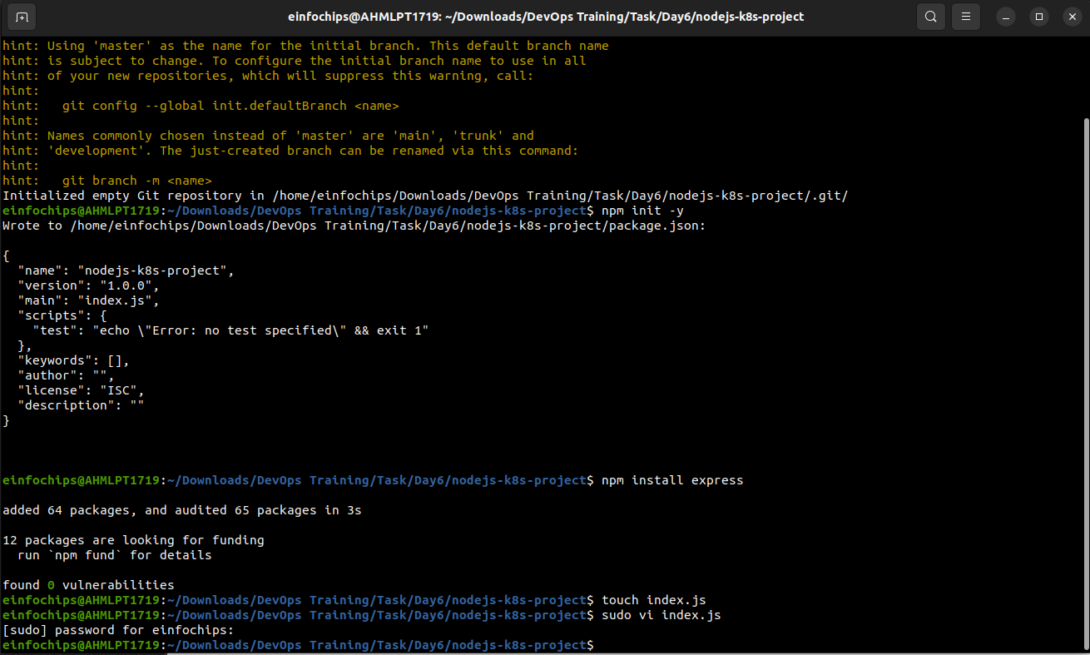

Create an index.js file with the following content:  
  
const express = require('express');

const app = express();

const port = 3000;

app.get('/', (req, res) => {

res.send('Hello, Kubernetes!');

});

app.listen(port, () => {

console.log(`App running at http://localhost:${port}`);

});

Create a .gitignore file to ignore node_modules:  
  
node_modules

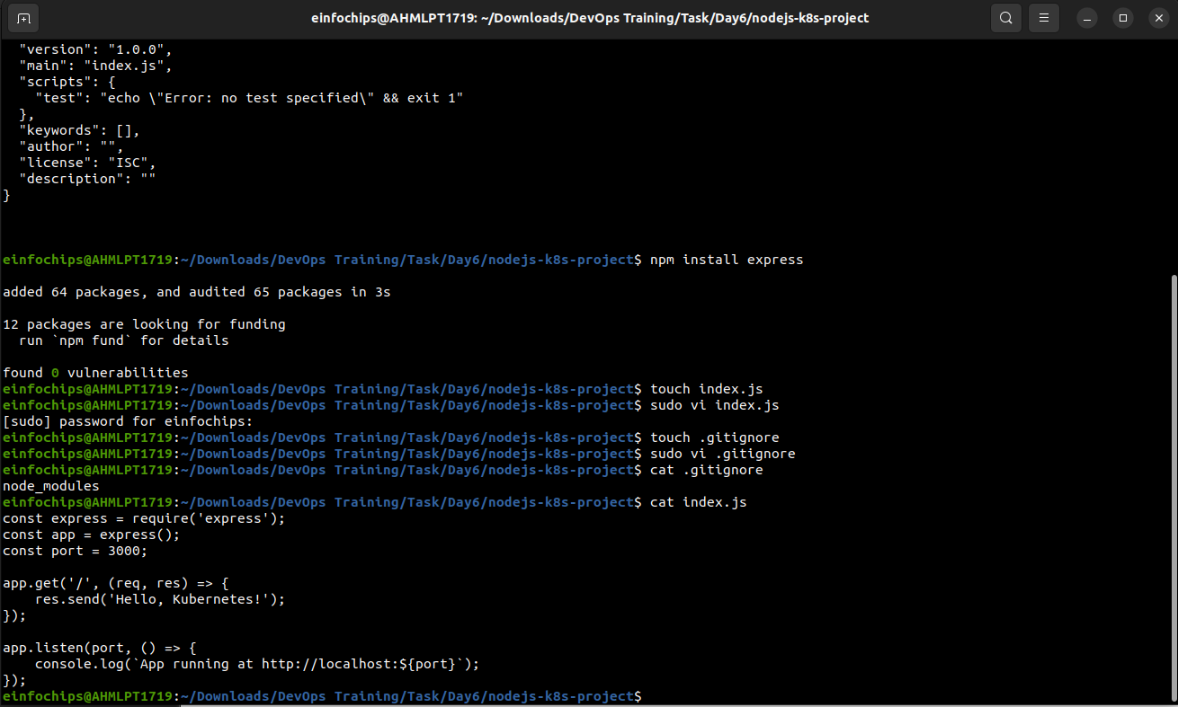

**1.3. Commit the Initial Code**

Add files to Git:  
  
git add .

Commit the changes:  
  
git commit -m "Initial commit with Node.js app"

### **2. Branching and Fast-Forward Merge**

**2.1. Create a New Branch**

Create and switch to a new branch feature/add-route:  
  
git checkout -b feature/add-route

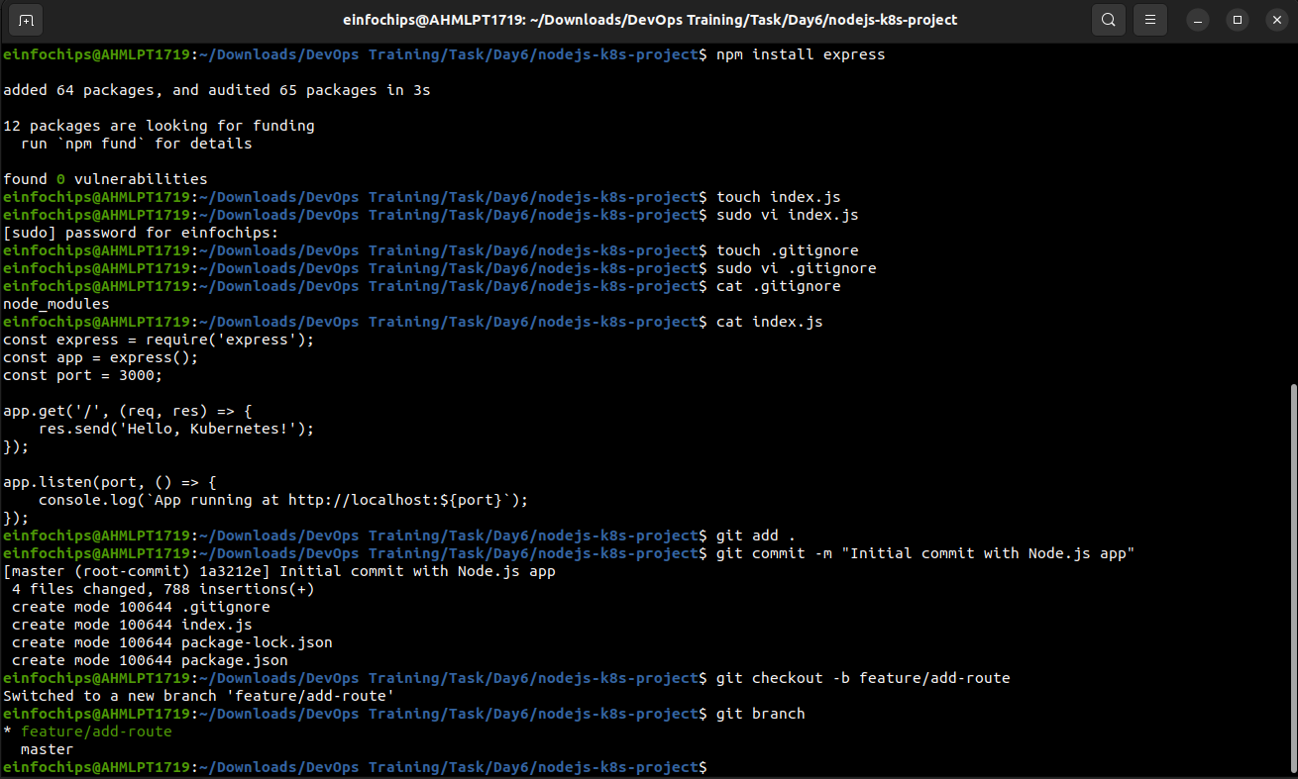

**2.2. Implement a New Route**

Modify index.js to add a new route:  
  
app.get('/newroute', (req, res) => {

res.send('This is a new route!');

});



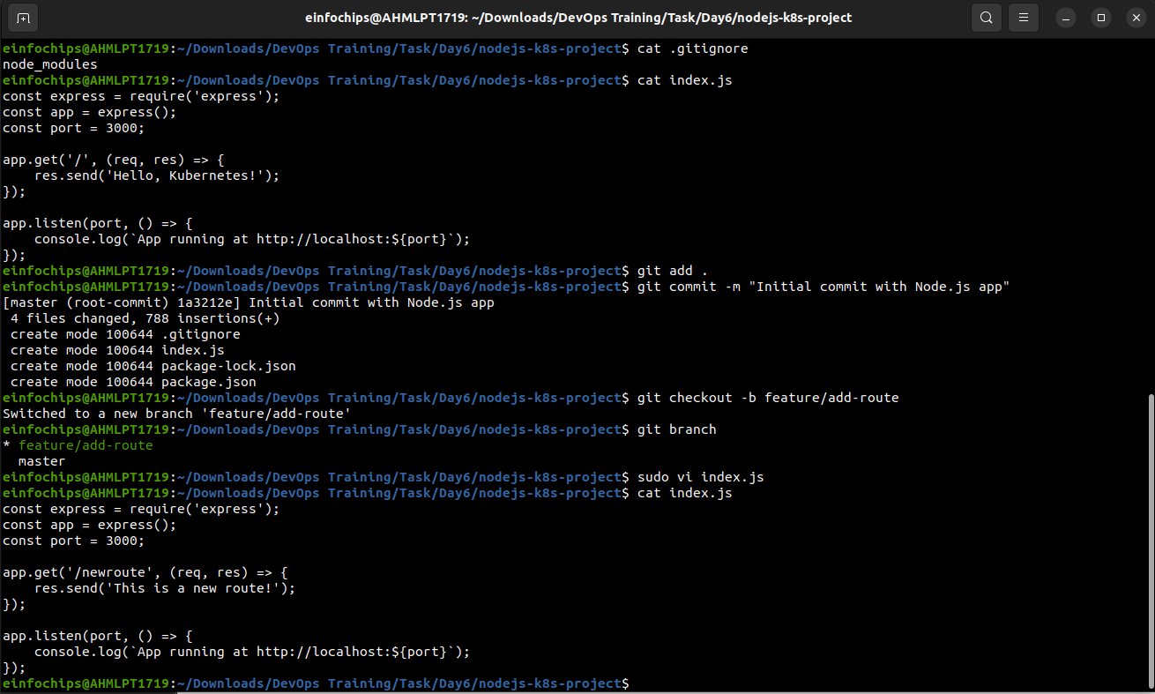

Commit the changes:  
  
git add .

git commit -m "Add new route"

**2.3. Merge the Branch Using Fast-Forward**

Switch back to the main branch:  
  
git checkout main

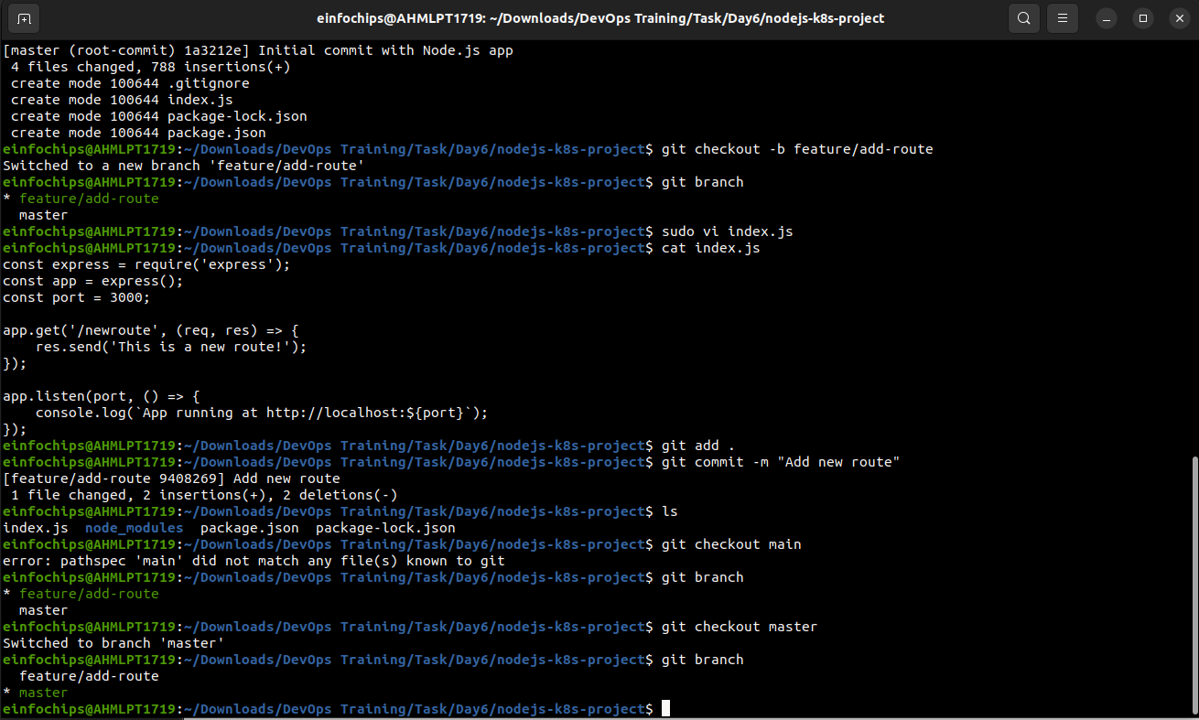

Merge the feature/add-route branch using fast-forward:  
  
git merge --ff-only feature/add-route

Delete the feature branch:  
  
git branch -d feature/add-route

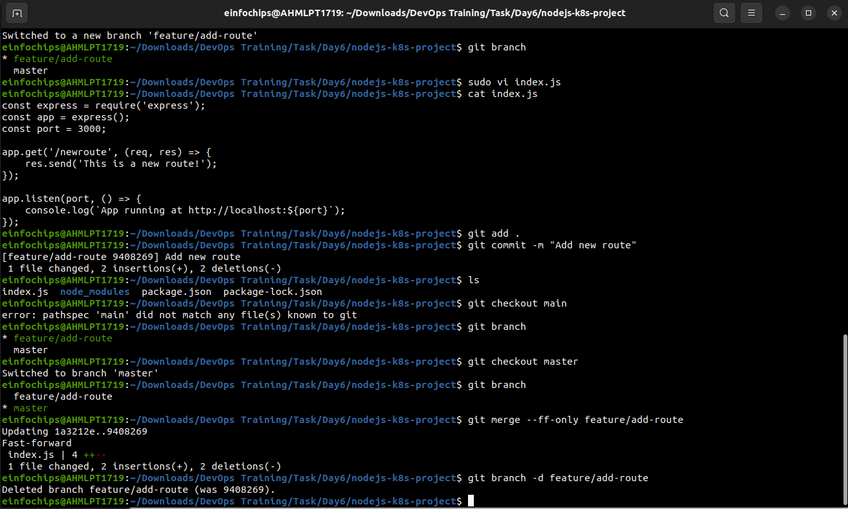

### **3. Containerize the Node.js Application**

**3.1. Create a Dockerfile**

Create a Dockerfile with the following content:  
  
FROM node:14

WORKDIR /app

COPY package*.json ./

RUN npm install

COPY . .

EXPOSE 3000

CMD ["node", "index.js"]

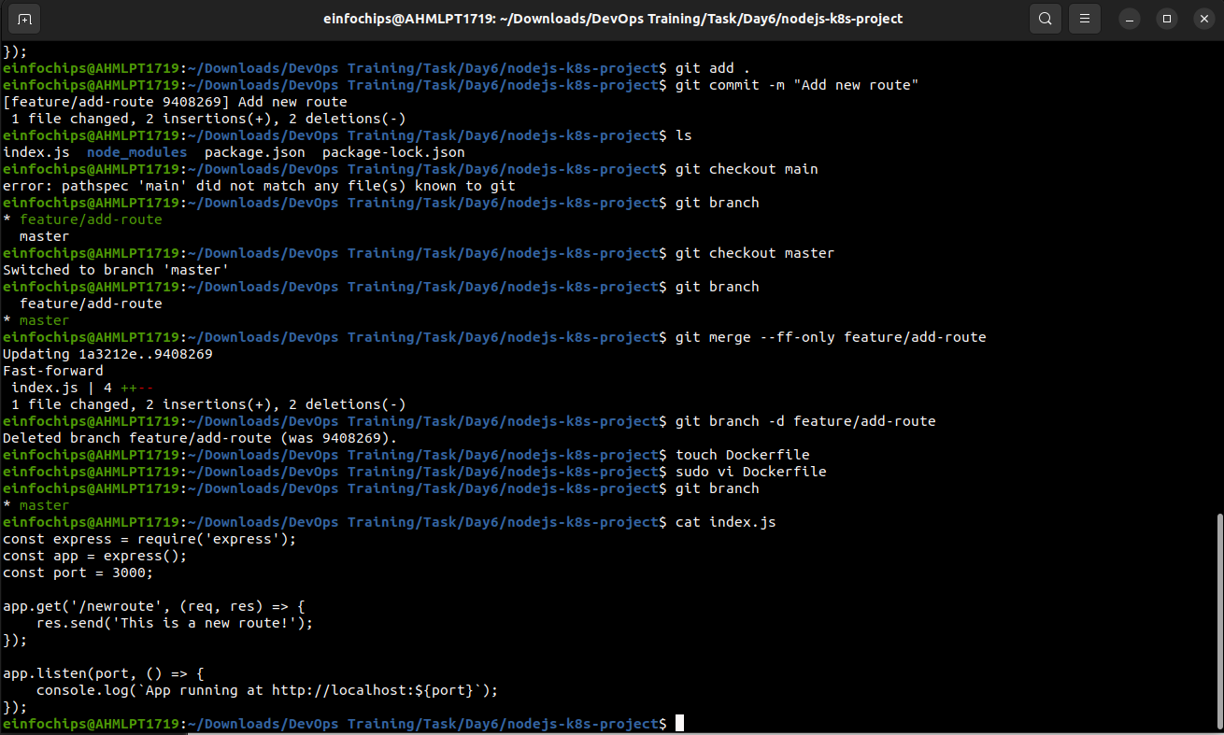

**3.2. Build and Test the Docker Image**

Build the Docker image:  
  
docker build -t nodejs-k8s-app .

Run the Docker container to test:  
  
docker run -p 3000:3000 nodejs-k8s-app

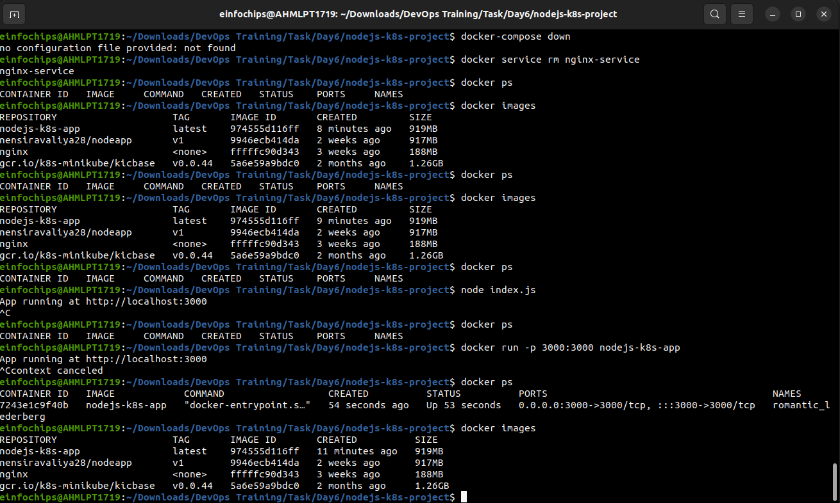

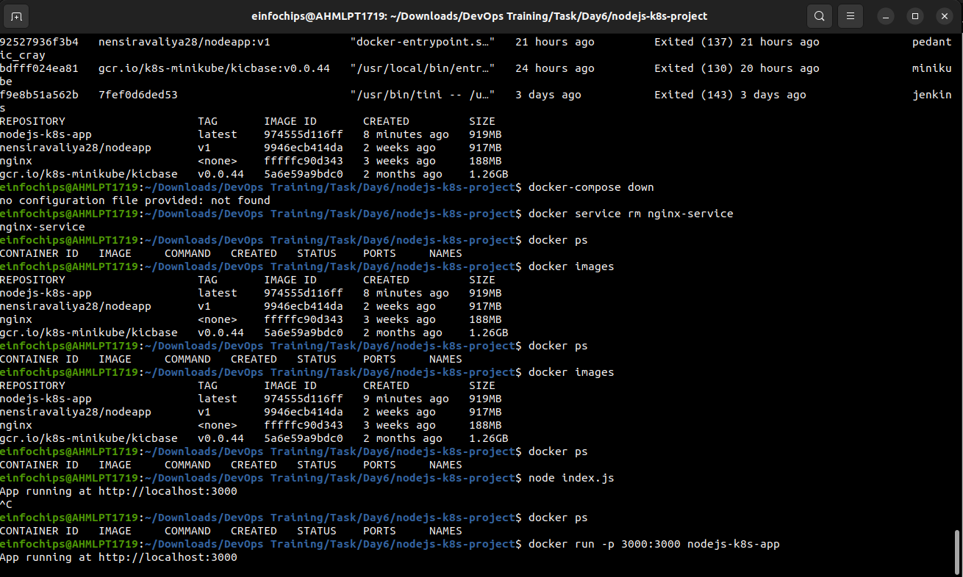

1. Access http://localhost:3000 to see the app running.

### **4. Deploying to Minikube Kubernetes**

**4.1. Start Minikube**

Start Minikube:

minikube start

**4.2. Create Kubernetes Deployment and Service Manifests**

Create a deployment.yaml file:  
  
apiVersion: apps/v1

kind: Deployment

metadata:

name: nodejs-app

spec:

replicas: 2

selector:

matchLabels:

app: nodejs-app

template:

metadata:

labels:

app: nodejs-app

spec:

containers:

- name: nodejs-app

image: nodejs-k8s-app:latest

ports:

- containerPort: 3000

Create a service.yaml file for ClusterIP:  
  
apiVersion: v1

kind: Service

metadata:

name: nodejs-service

spec:

selector:

app: nodejs-app

ports:

- protocol: TCP

port: 80

targetPort: 3000

type: ClusterIP

Create a service-nodeport.yaml file for NodePort:  
  
apiVersion: v1

kind: Service

metadata:

name: nodejs-service-nodeport

spec:

selector:

app: nodejs-app

ports:

- protocol: TCP

port: 80

targetPort: 3000

nodePort: 30001

type: NodePort

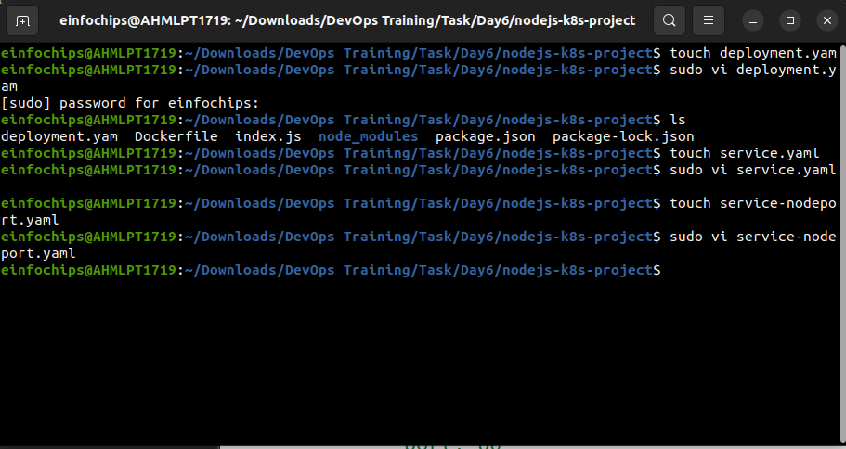

**4.3. Apply Manifests to Minikube**

Apply the deployment:  
  
kubectl apply -f deployment.yaml

Apply the ClusterIP service:  
  
kubectl apply -f service.yaml

Apply the NodePort service:  
  
kubectl apply -f service-nodeport.yaml

**4.4. Access the Application**

Get the Minikube IP:  
  
minikube ip

1. Access the application using the NodePort:  
     
   curl http://<minikube-ip>:30001

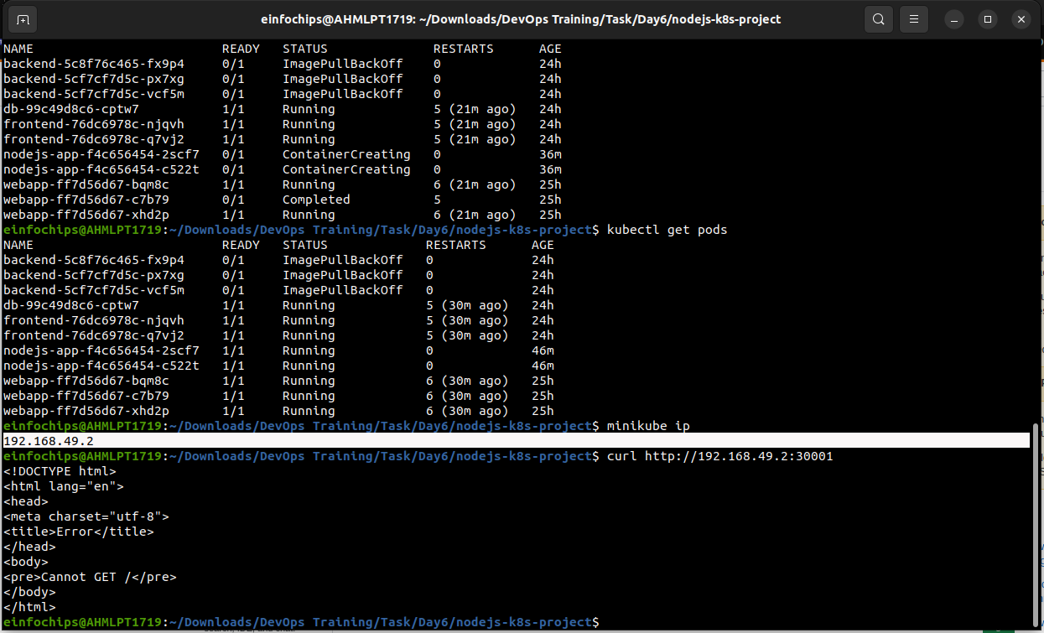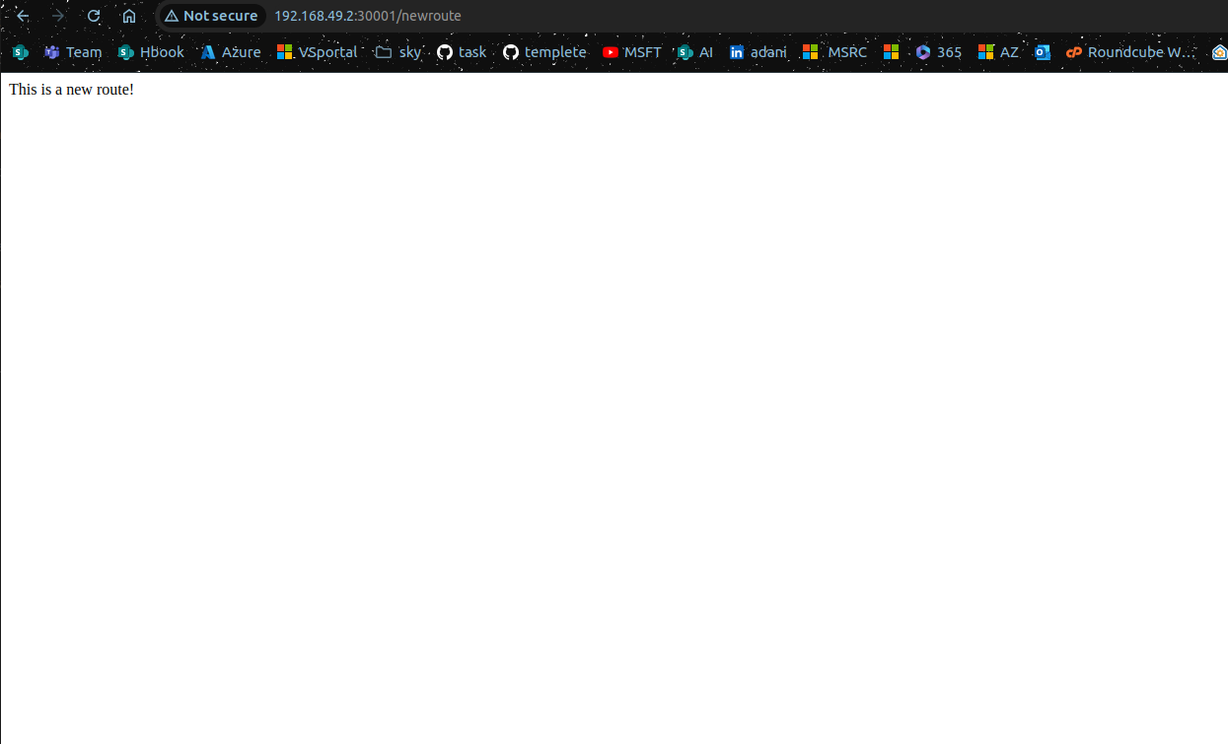

### **Making Changes to the App and Redeploying Using Kubernetes**

### **6. Making Changes to the Node.js Application**

**6.1. Create a New Branch for Changes**

Create and switch to a new branch feature/update-message:  
  
git checkout -b feature/update-message

**6.2. Update the Application**

Modify index.js to change the message:  
  
const express = require('express');

const app = express();

const port = 3000;

app.get('/', (req, res) => {

res.send('Hello, Kubernetes! Updated version.');

});

app.get('/newroute', (req, res) => {

res.send('This is a new route!');

});

app.listen(port, () => {

console.log(`App running at http://localhost:${port}`);

});

**6.3. Commit the Changes**

Add and commit the changes:  
  
git add .

git commit -m "Update main route message"

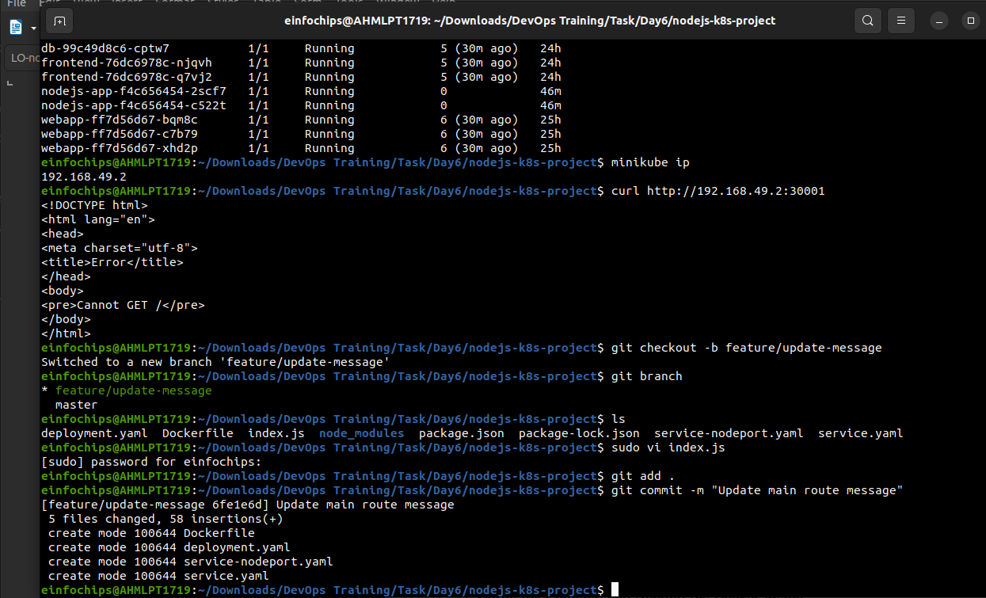

### **7. Merge the Changes and Rebuild the Docker Image**

**7.1. Merge the Feature Branch**

Switch back to the main branch:  
  
git checkout main

Merge the feature/update-message branch:  
  
git merge --ff-only feature/update-message

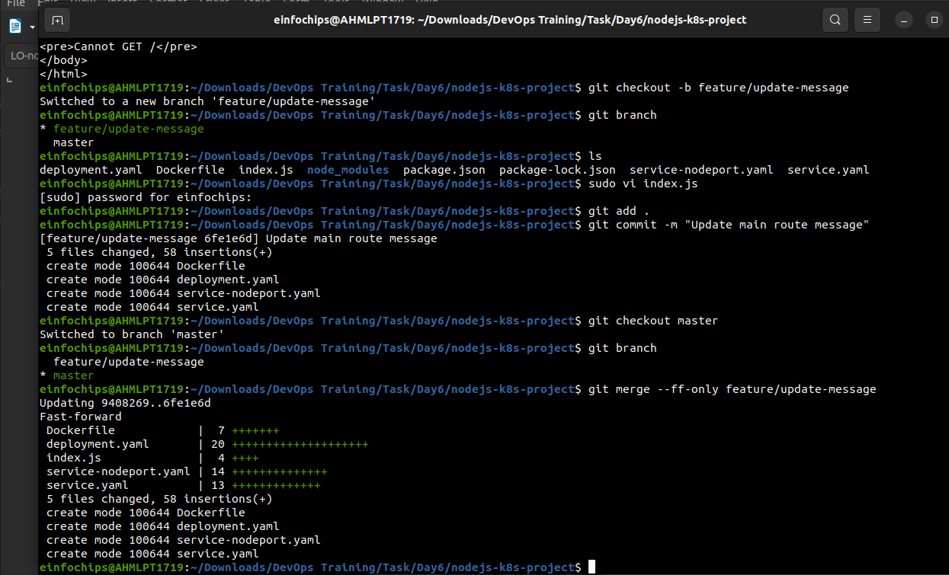

Delete the feature branch:  
  
git branch -d feature/update-message

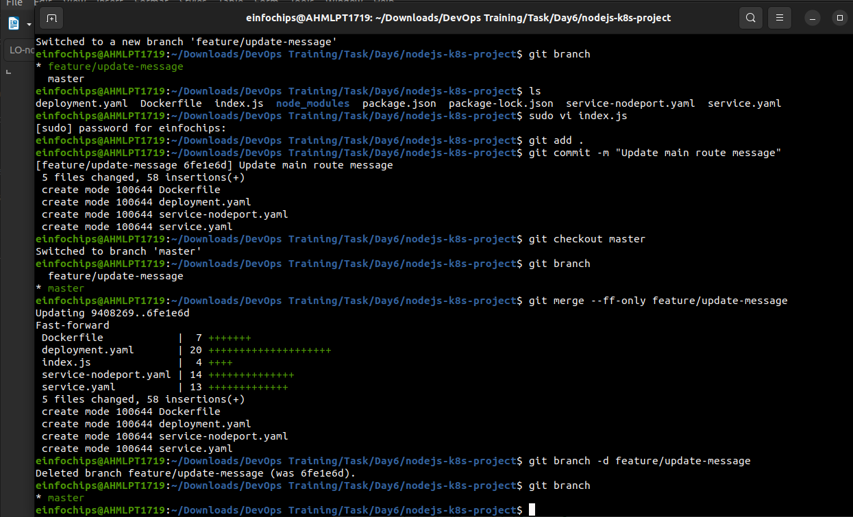

**7.2. Rebuild the Docker Image**

Rebuild the Docker image with a new tag:  
  
docker build -t nodejs-k8s-app:v2 .

### **8. Update Kubernetes Deployment**

**8.1. Update the Deployment Manifest**

Modify deployment.yaml to use the new image version:  
  
apiVersion: apps/v1

kind: Deployment

metadata:

name: nodejs-app

spec:

replicas: 2

selector:

matchLabels:

app: nodejs-app

template:

metadata:

labels:

app: nodejs-app

spec:

containers:

- name: nodejs-app

image: nodejs-k8s-app:v2

ports:

- containerPort: 3000

**8.2. Apply the Updated Manifest**

Apply the updated deployment:  
  
kubectl apply -f deployment.yaml

**8.3. Verify the Update**

Check the status of the deployment:  
  
kubectl rollout status deployment/nodejs-app

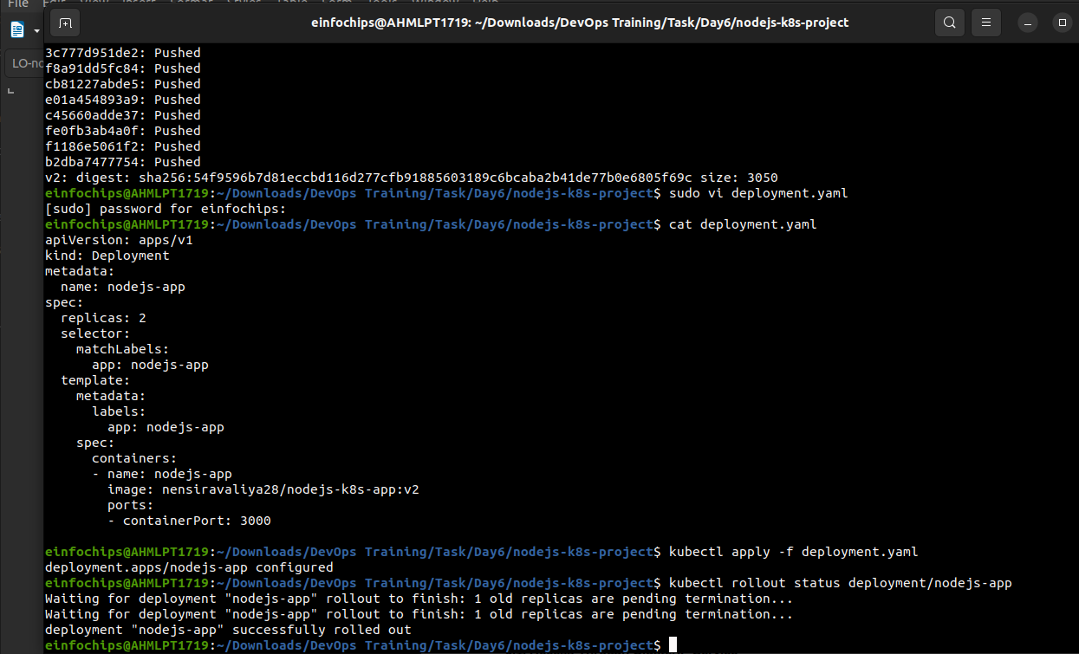

### **9. Access the Updated Application**

**9.1. Access Through ClusterIP Service**

Forward the port to access the ClusterIP service:  
  
kubectl port-forward service/nodejs-service 8080:80

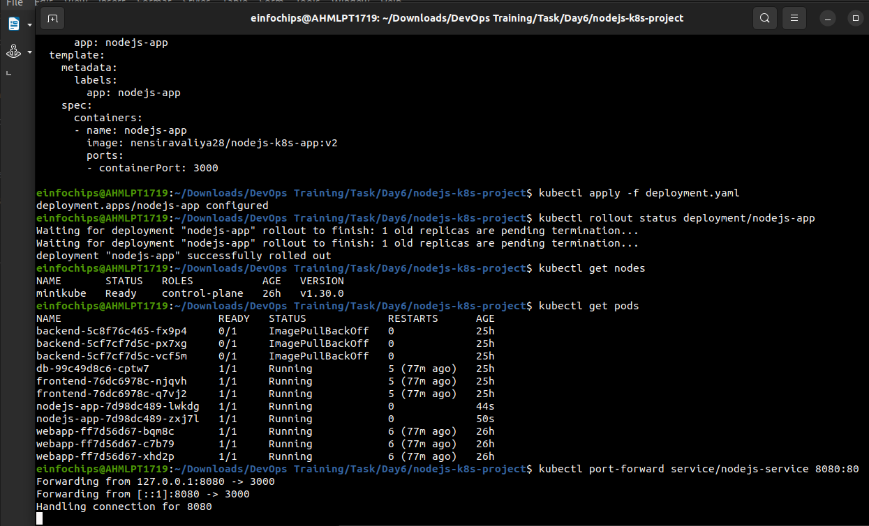

1. Open your browser and navigate to http://localhost:8080 to see the updated message.

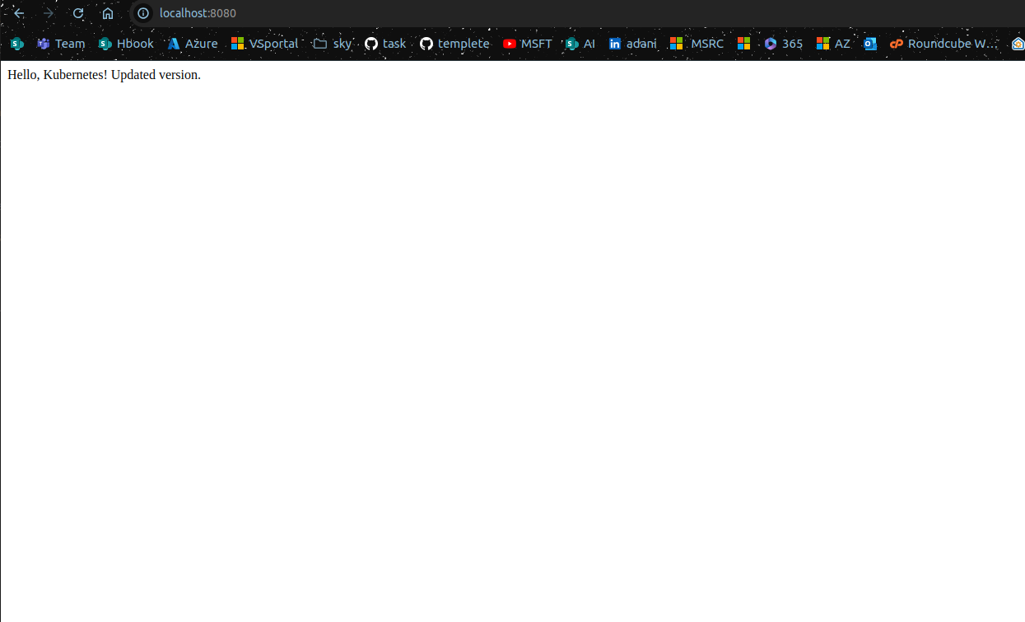

**9.2. Access Through NodePort Service**

1. Access the application using the NodePort:  
     
   curl http://<minikube-ip>:30001

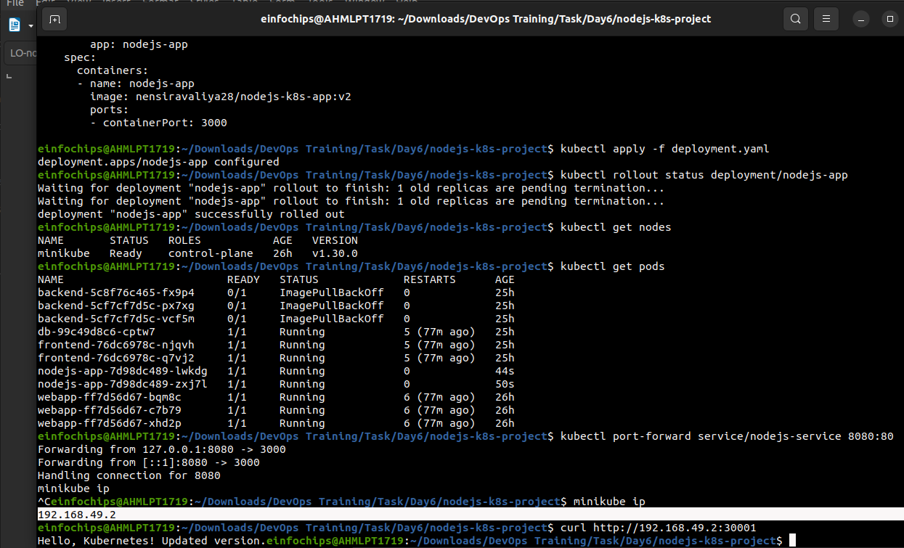

**Project 02**

### **Deploying a Python Flask App Using Minikube Kubernetes**

#### **Overview**

This project guides you through deploying a Python Flask application using Minikube Kubernetes. You'll use Git for version control, explore branching and fast-forward merges, and set up Kubernetes services and deployment pods, including ClusterIP and NodePort service types.

#### **Prerequisites**

* Minikube installed
* kubectl installed
* Git installed
* Python installed

#### **Project Steps**

### **1. Set Up Git Version Control**

**1.1. Initialize a Git Repository**

Create a new directory for your project:  
  
mkdir flask-k8s-project

cd flask-k8s-project

Initialize a Git repository:  
sh  
Copy code  
git init

**1.2. Create a Python Flask Application**

Create a virtual environment:  
  
python -m venv venv

source venv/bin/activate

Install Flask:  
sh  
Copy code  
pip install Flask

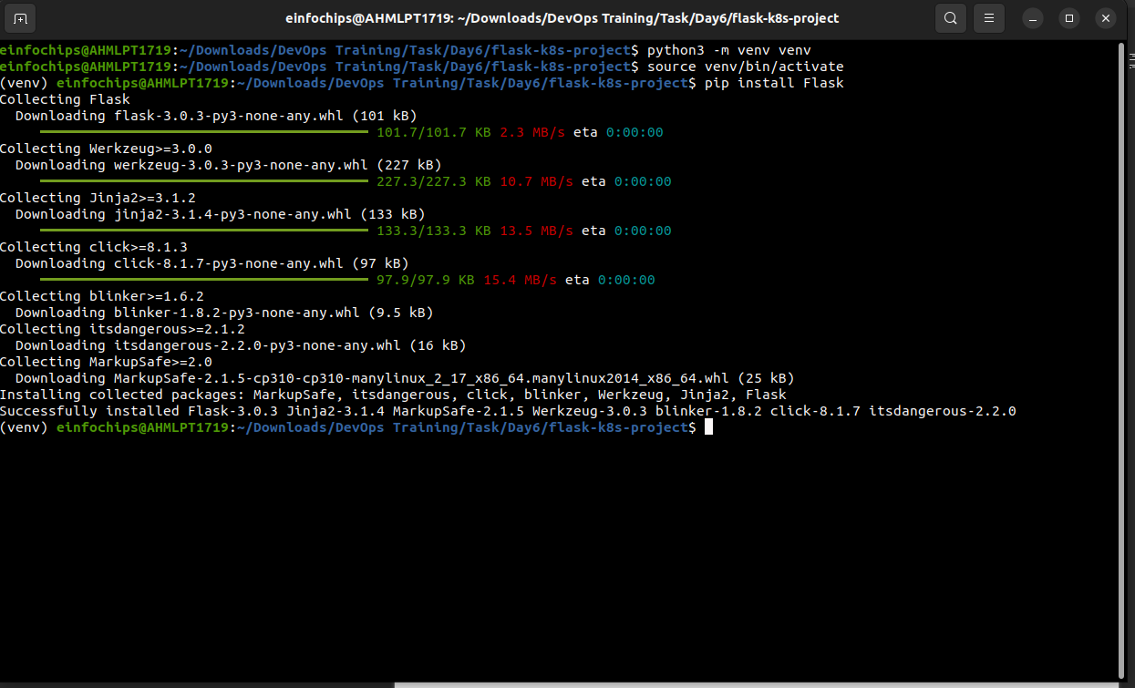

Create an app.py file with the following content:  
python  
Copy code  
from flask import Flask

app = Flask(__name__)

@app.route('/')

def hello_world():

return 'Hello, Kubernetes!'

if __name__ == '__main__':

app.run(host='0.0.0.0', port=5000)

Create a requirements.txt file to list the dependencies:  
Copy code  
Flask

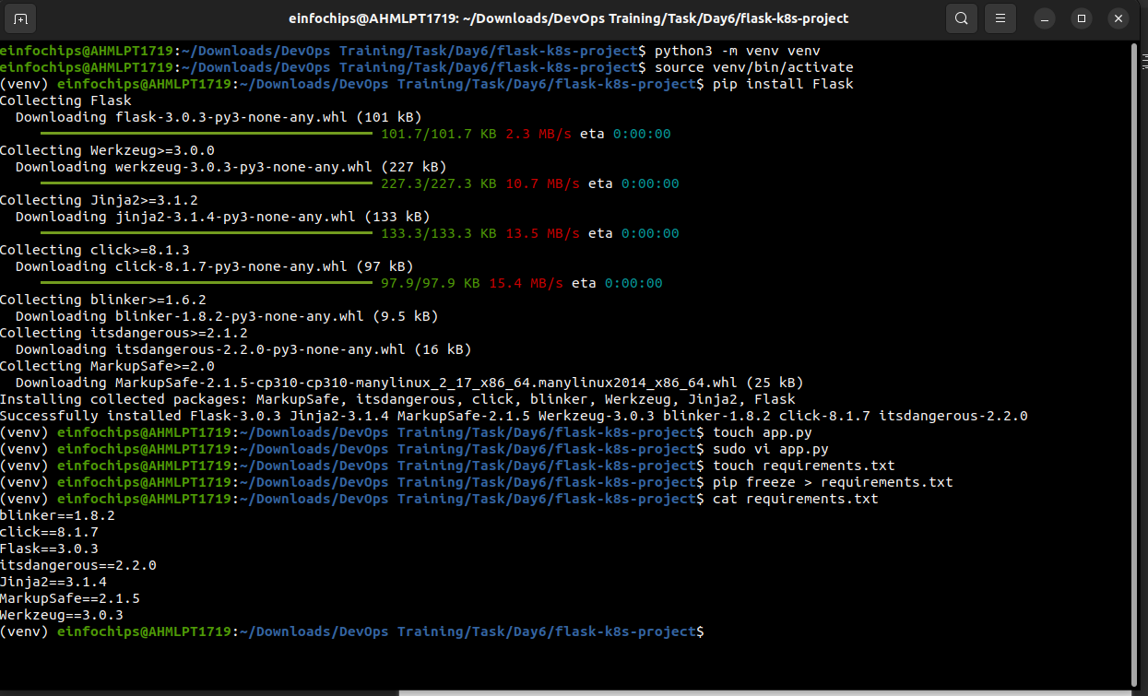

Create a .gitignore file to ignore venv:  
Copy code  
venv

**1.3. Commit the Initial Code**

Add files to Git:  
  
git add .

Commit the changes:  
  
git commit -m "Initial commit with Flask app"

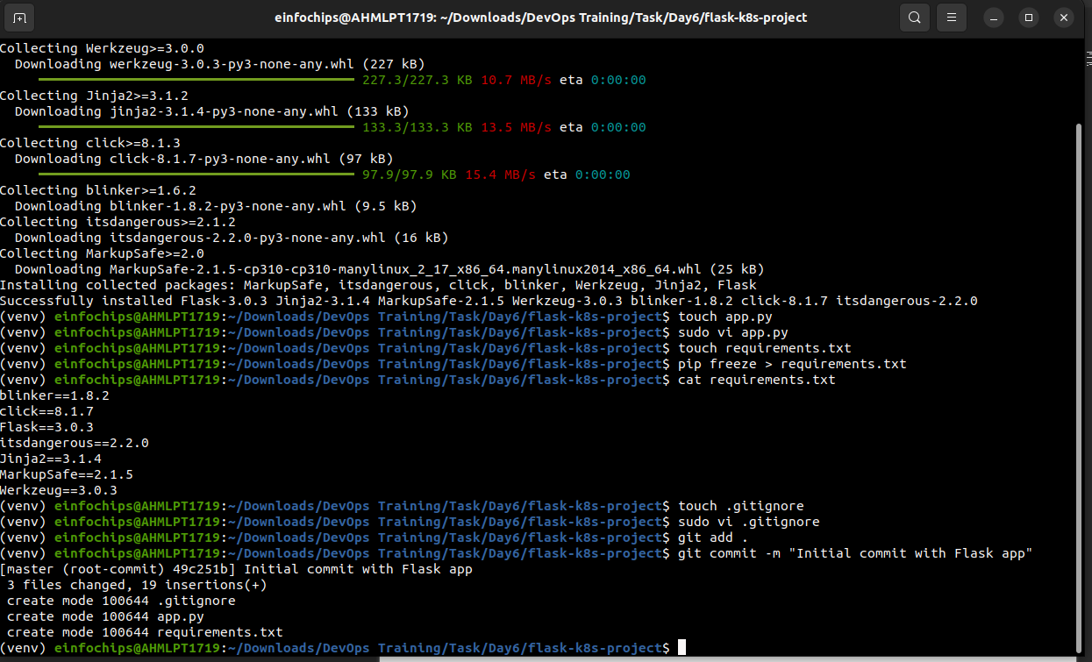

### **2. Branching and Fast-Forward Merge**

**2.1. Create a New Branch**

Create and switch to a new branch feature/add-route:  
  
git checkout -b feature/add-route

**2.2. Implement a New Route**

Modify app.py to add a new route:  
  
@app.route('/newroute')

def new_route():

return 'This is a new route!'

Commit the changes:  
  
git add .

git commit -m "Add new route"

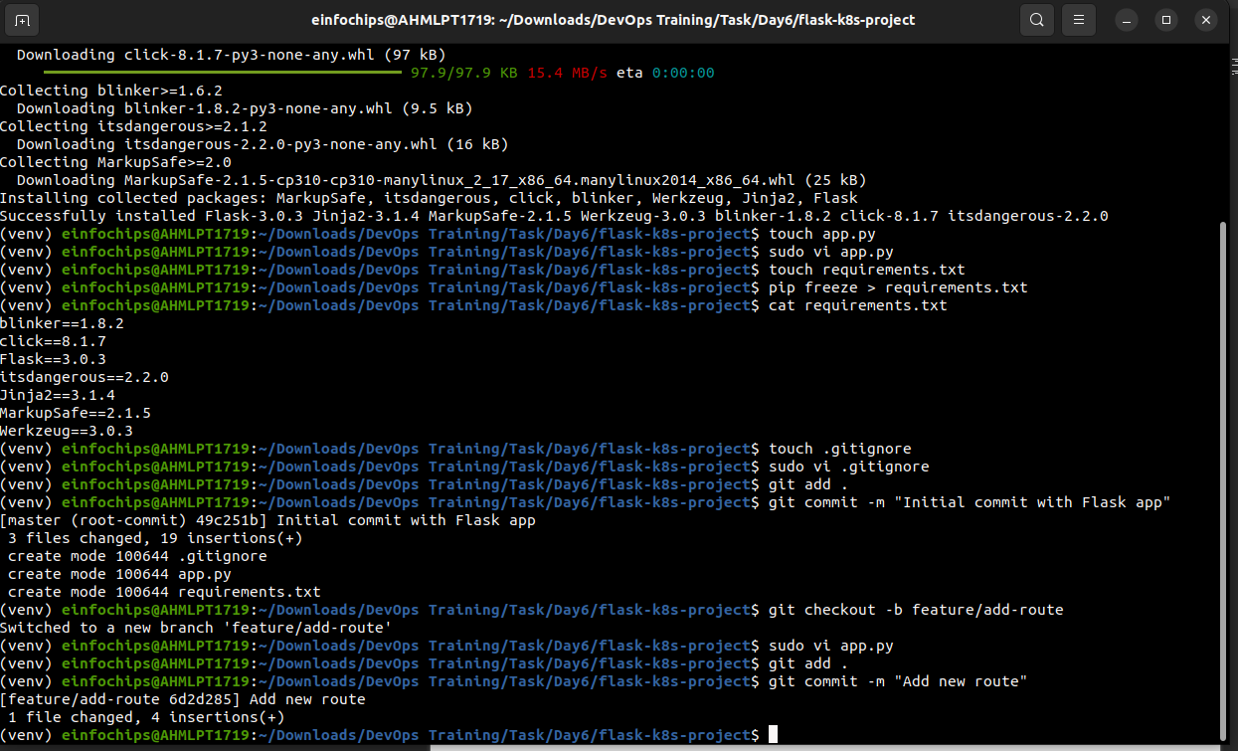

**2.3. Merge the Branch Using Fast-Forward**

Switch back to the main branch:  
  
git checkout main

Merge the feature/add-route branch using fast-forward:  
  
git merge --ff-only feature/add-route

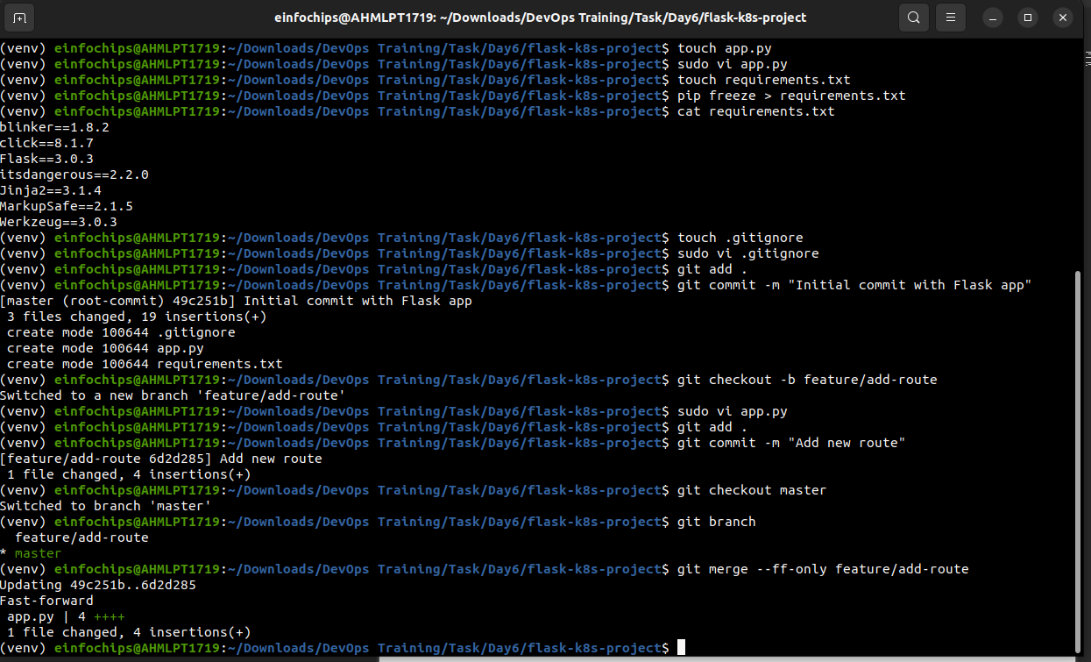

Delete the feature branch:  
  
git branch -d feature/add-route

### **3. Containerize the Flask Application**

**3.1. Create a Dockerfile**

Create a Dockerfile with the following content:  
  
FROM python:3.8-slim

WORKDIR /app

COPY requirements.txt requirements.txt

RUN pip install -r requirements.txt

COPY . .

EXPOSE 5000

CMD ["python", "app.py"]

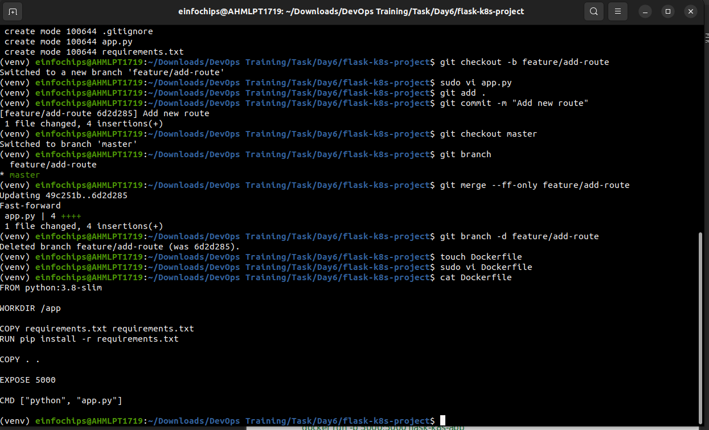

**3.2. Build and Test the Docker Image**

Build the Docker image:  
  
docker build -t flask-k8s-app .

Run the Docker container to test:  
  
docker run -p 5000:5000 flask-k8s-app

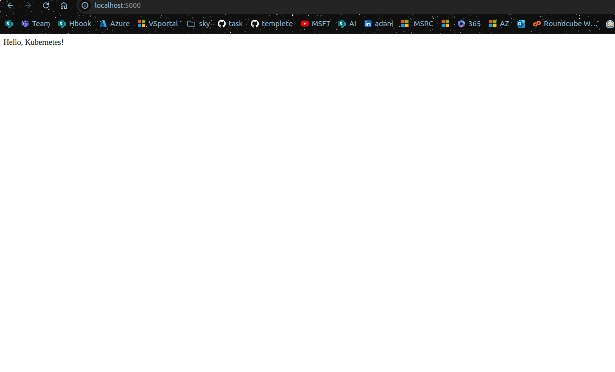

1. Access http://localhost:5000 to see the app running.

### **4. Deploying to Minikube Kubernetes**

**4.1. Start Minikube**

Start Minikube:  
  
minikube start

**4.2. Create Kubernetes Deployment and Service Manifests**

Create a deployment.yaml file:  
  
apiVersion: apps/v1

kind: Deployment

metadata:

name: flask-app

spec:

replicas: 2

selector:

matchLabels:

app: flask-app

template:

metadata:

labels:

app: flask-app

spec:

containers:

- name: flask-app

image: flask-k8s-app:latest

ports:

- containerPort: 5000

Create a service.yaml file for ClusterIP:  
  
apiVersion: v1

kind: Service

metadata:

name: flask-service

spec:

selector:

app: flask-app

ports:

- protocol: TCP

port: 80

targetPort: 5000

type: ClusterIP

Create a service-nodeport.yaml file for NodePort:  
  
apiVersion: v1

kind: Service

metadata:

name: flask-service-nodeport

spec:

selector:

app: flask-app

ports:

- protocol: TCP

port: 80

targetPort: 5000

nodePort: 30001

type: NodePort

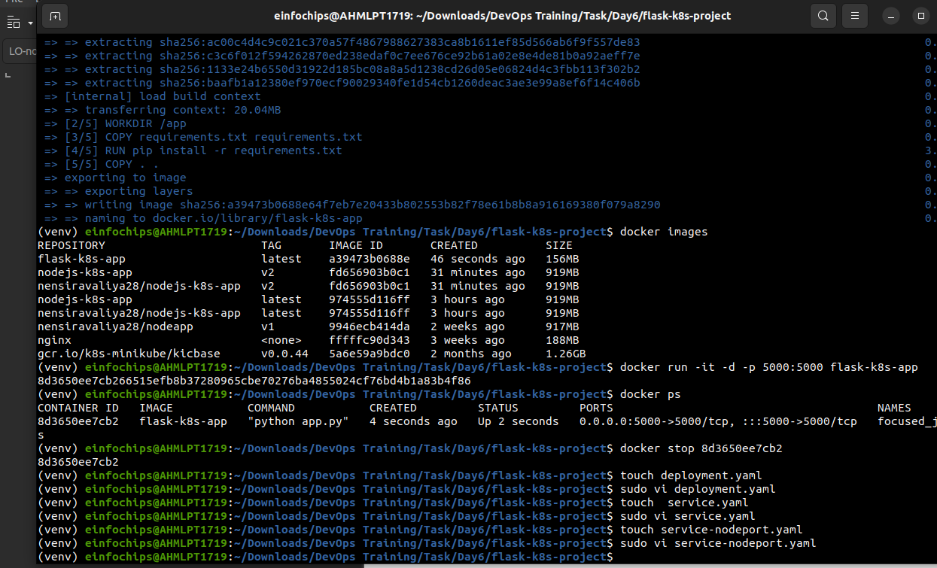

**4.3. Apply Manifests to Minikube**

Apply the deployment:  
  
kubectl apply -f deployment.yaml

Apply the ClusterIP service:  
  
kubectl apply -f service.yaml

Apply the NodePort service:  
  
kubectl apply -f service-nodeport.yaml

**4.4. Access the Application**

Get the Minikube IP:  
  
minikube ip

Access the application using the NodePort:  
  
curl http://<minikube-ip>:30001

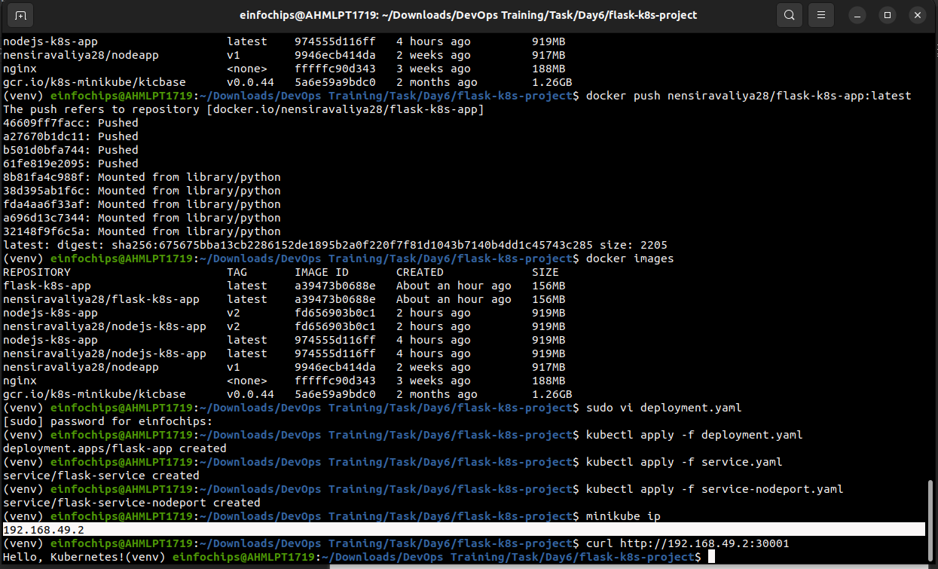

### **5. Clean Up**

Stop Minikube:  
  
minikube stop

Delete Minikube cluster:  
  
minikube delete

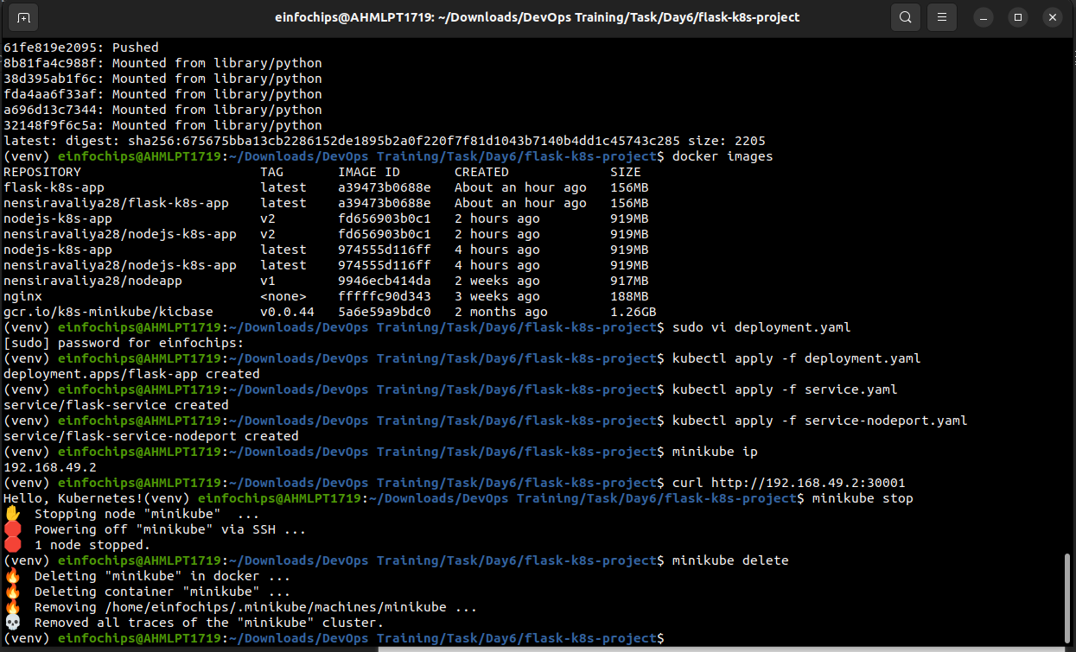

### **6. Making Changes to the Flask Application**

**6.1. Create a New Branch for Changes**

Create and switch to a new branch feature/update-message:  
  
git checkout -b feature/update-message

**6.2. Update the Application**

Modify app.py to change the message:  
  
@app.route('/')

def hello_world():

return 'Hello, Kubernetes! Updated version.'

@app.route('/newroute')

def new_route():

return 'This is a new route!'

**6.3. Commit the Changes**

Add and commit the changes:  
  
git add .

git commit -m "Update main route message"

### **7. Merge the Changes and Rebuild the Docker Image**

**7.1. Merge the Feature Branch**

Switch back to the main branch:  
  
git checkout main

Merge the feature/update-message branch:  
  
git merge --ff-only feature/update-message

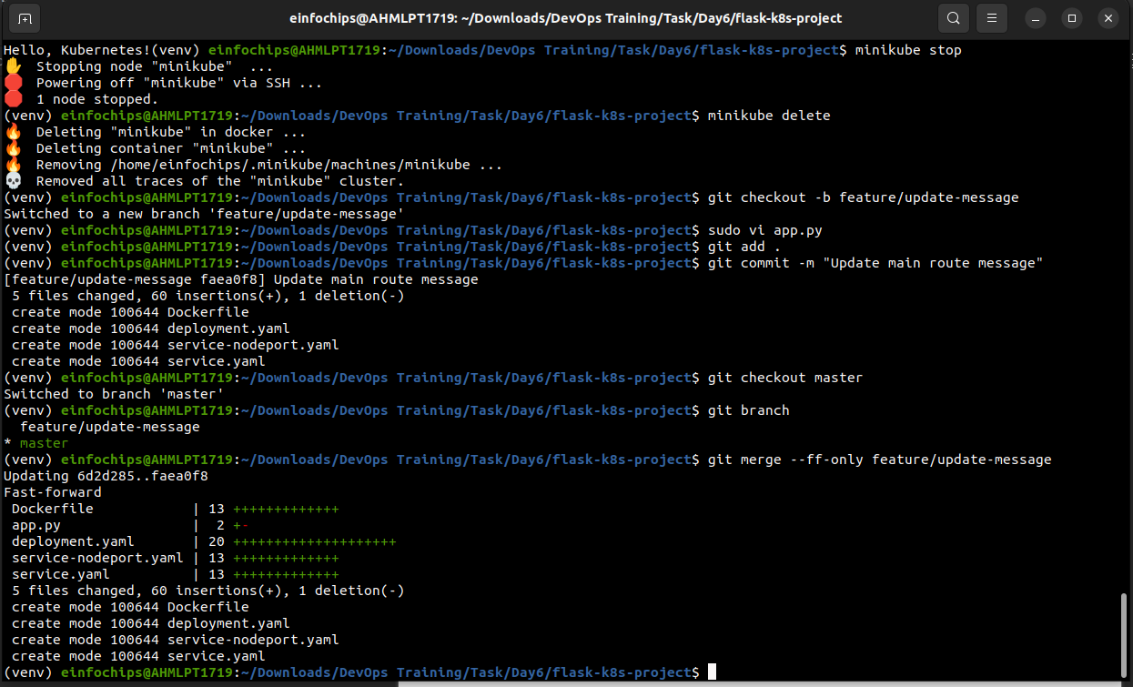

Delete the feature branch:  
  
git branch -d feature/update-message

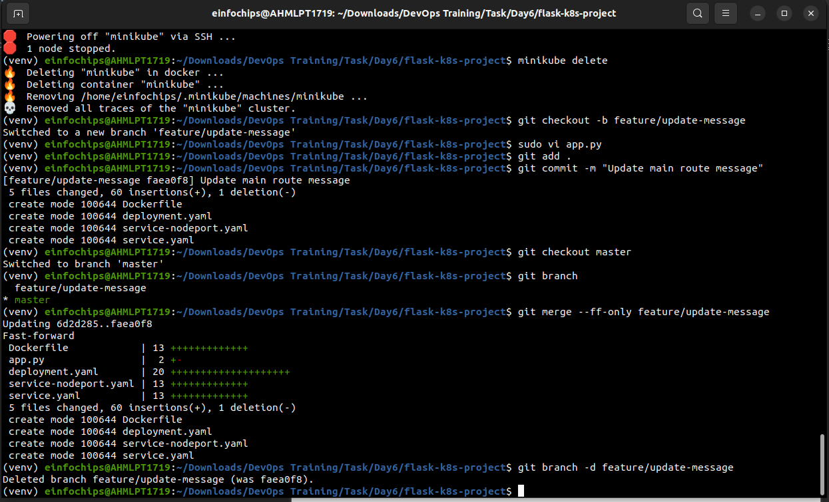

**7.2. Rebuild the Docker Image**

Rebuild the Docker image with a new tag:  
  
docker build -t flask-k8s-app:v2 .

### **8. Update Kubernetes Deployment**

**8.1. Update the Deployment Manifest**

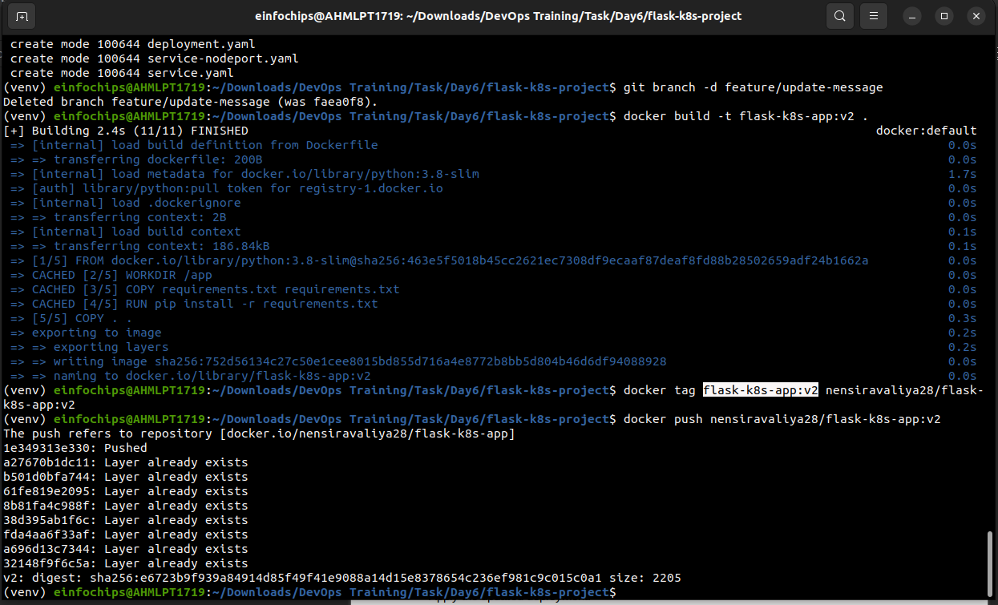

Modify deployment.yaml to use the new image version:  
  
apiVersion: apps/v1

kind: Deployment

metadata:

name: flask-app

spec:

replicas: 2

selector:

matchLabels:

app: flask-app

template:

metadata:

labels:

app: flask-app

spec:

containers:

- name: flask-app

image: flask-k8s-app:v2

ports:

- containerPort: 5000

**8.2. Apply the Updated Manifest**

Apply the updated deployment:  
sh  
Copy code  
kubectl apply -f deployment.yaml

**8.3. Verify the Update**

Check the status of the deployment:  
sh  
Copy code  
kubectl rollout status deployment/flask-app

### **9. Access the Updated Application**

**9.1. Access Through ClusterIP Service**

Forward the port to access the ClusterIP service:  
  
kubectl port-forward service/flask-service 8080:80

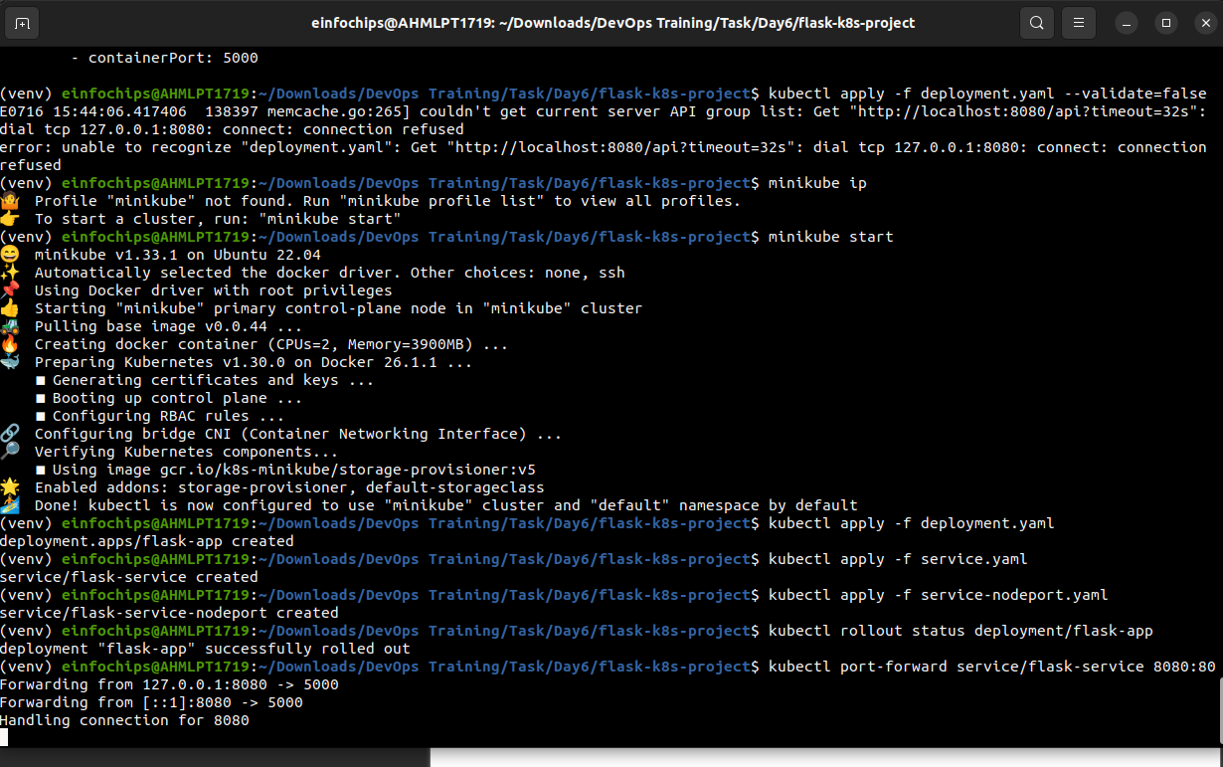

1. Open your browser and navigate to http://localhost:8080 to see the updated message.

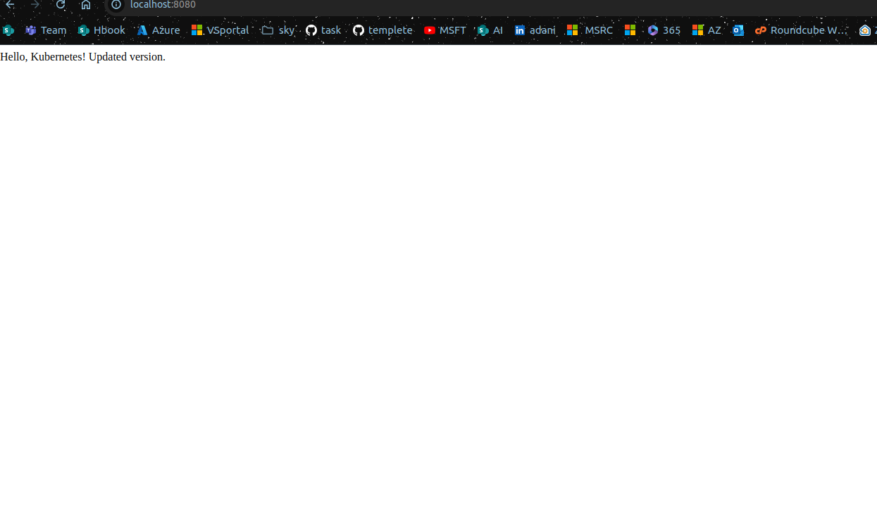

**9.2. Access Through NodePort Service**

1. Access the application using the NodePort:  
     
   curl http://<minikube-ip>:30001

